**Objective Questions**:

1. What is the total no. of tables present in the data?

* ANSWER:- 2 (Row data and Country Description ).

1. What is the total no. of attributes present in the data?

* ANSWER:- * Row Data has 20 columns.

* Country Description has 2 columns.

1. How many categorical columns are there in the data? [Search about categorical and continuous data, and try to answer this question]

* ANSWER:- Countrycode, City ,currency, has_table_booking , has_online_delivery , is_delivery_now, switch_to_order,Price_range.

1. The data consists of some inconsistent and missing values so ensure that the data used for further analysis is cleaned

* ANSWER:- first we find the duplicate or missing values and the then separate the Datekey_Opening and get year column. Use find and replace function.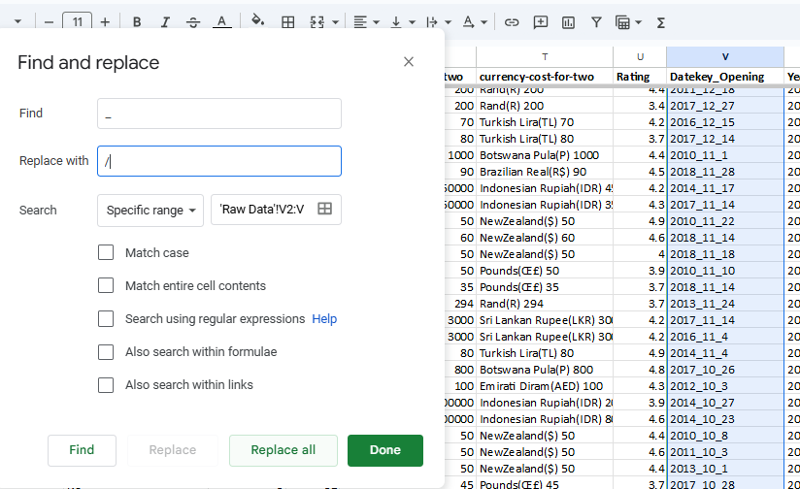

1. Using the LookUp functions, fill up the countries in the original data using the country code.

* ANSWER:-=XLOOKUP(C2,'country description'!$A$2:$A$16,'country description'!$B$2:$B$16,"NOT FOUND")

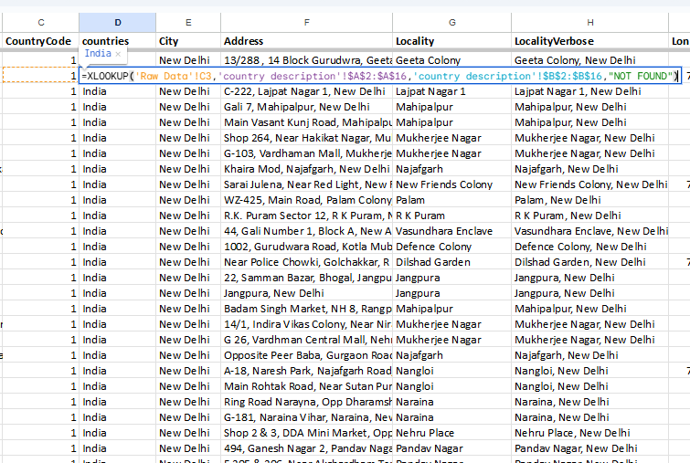

1. Create a table to represent the number of restaurants opened in each country.

ANSWER:- the number of restaurants opened in each country through pivot table.

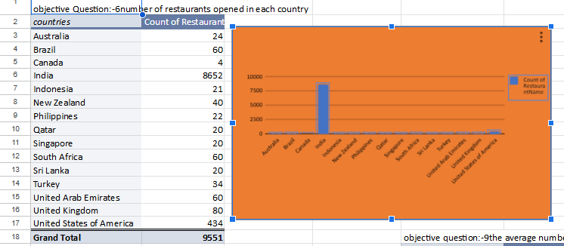

1. Also, the management wants to look at the number of restaurants opened each year, so provide them with something here.

* ANSWER:- use pivot table to get the number of restaurants opened each year

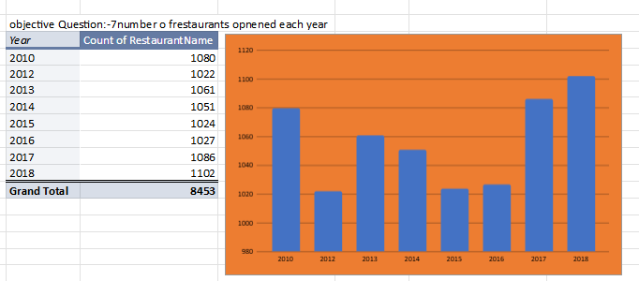

1. What is the total number of restaurants in India in the price range of 4?

* ANSWER:-

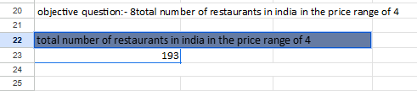

1. What is the average number of voters for the restaurants in each country according to the data?

* ANSWER:- pivot table to get the average number of voters in each country.

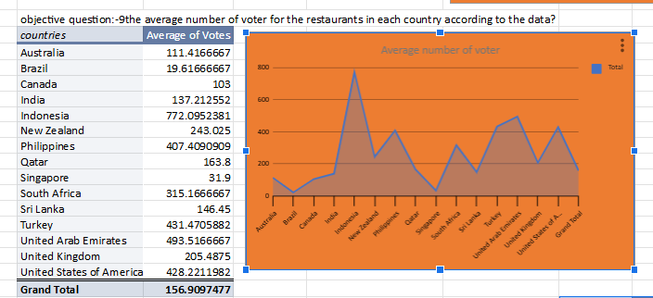

1. Calculate the average rating for all the restaurants that have price_range < 4 and provide online delivery. Use only the “IF” function, Logical Operators, and Aggregation functions to solve this problem. **[Note: Don’t use Conditional aggregation in this question.]**

* ANSWER:-=AVERAGE(IF(('Raw Data'!Q2:Q9552<4)*('Raw Data'!N2:N9552="yes"), 'Raw Data'!U2:U9552))

1. Create a new customized price column that consists of the abbreviation/symbol of the currency along with the Average_cost_for_two value. [Use string operations to do this task]

* ANSWER:- Use string operations to new customized price column that consists of the abbreviation/symbol of the currency along with the Average_cost_for_two value.

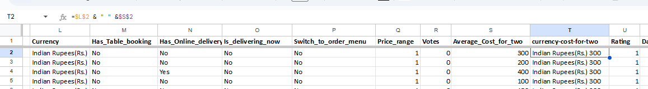

1. How can you create an array formula in Excel or Google Sheets to count the number of restaurants listed that do not offer online delivery, are in the lowest price range, and have an average cost for two people less than or equal to 250 Indian Rupees?

* ANSWER:- =ARRAYFORMULA(SUM(('Raw Data'!N2:N9552="NO")*('Raw Data'!Q2:Q9552=1)*('Raw Data'!S2:S9552<=250)))

**Subjective Question:**

1. Suggest a few countries where the team can open newer restaurants with lesser competition. Which visualization/technique will you use here to justify the suggestions?

* ANSWER:- use line graph for visualization as it is easier to distinguish which country has more restaurants and less restaurants.

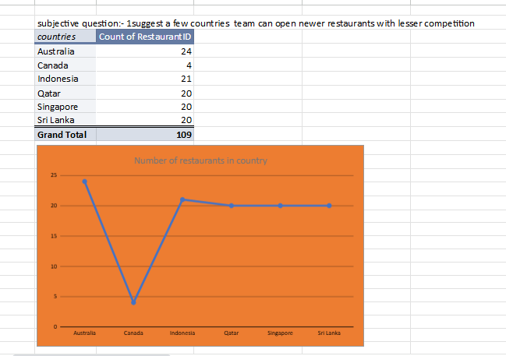

1. Come up with the names of States and cities in the suggested countries suitable for opening restaurants.

* ANSWER:- the number of restaurants low in cities we consider that it suitable for opening restaurants with less competition

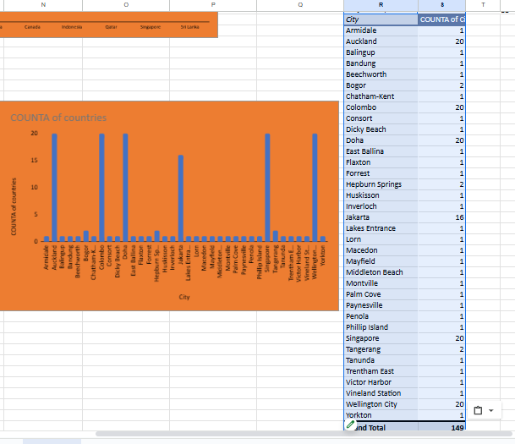

1. According to the countries you suggested, what is the current quality regarding ratings for restaurants that are open there?

* ANSWER:-

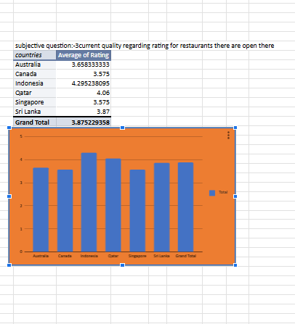

1. Also, what is the current expenditure on food in the suggested countries, so we can keep our financial expenditure in control?

ANSWER:-

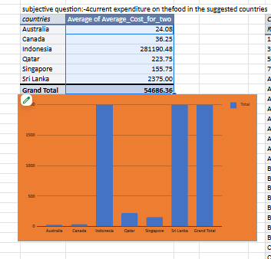

1. Come up with the names of restaurants from the recommended states that are our biggest competitors and also those that are rated in the lower brackets, i.e. 1-2 or 2-3.

ANSWER:-A: name of biggest competitors restaurants

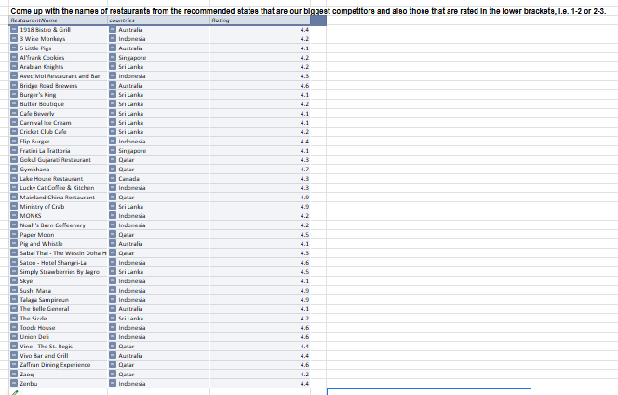

B:names of restaurants those that are rated in the lower brackets, i.e. 1-2 or 2-3

* Elite Indian Restaurant
* Pier 70
* Poets Cafe
* Queen's Cafe
* Star Buffet

1. Which cuisines should we focus on in the newer restaurants to get better feedback? Does the choice of cuisines affect the restaurant ratings?

ANSWER:-this cuisines should focus on the newer restaurants to get better

Feedback and of course the choice of cuisines affect the restaurant

Ratings

* Brazilian, Italian, South Indian, Japanese, Kashmiri, Malaysian, Mediterranean, Mexican, mithai, Bengali, European, Mughlai, South Indian, thai ,Spanish ,African ,American

1. According to our current data, should we go for online delivery and table booking? Does that affect the customer’s ratings?

ANSWER:- **The Short Answer: It Depends**

While online delivery and table booking can significantly enhance a restaurant's customer experience and boost revenue, their impact on customer ratings is multifaceted and depends on various factors:

**Positive Impacts:**

* **Convenience:** These services offer convenience to customers, saving them time and effort.
* **Accessibility:** Online delivery expands your customer base, reaching those who may not be able to dine in.
* **Data-Driven Insights:** Table booking systems can provide valuable data on customer preferences, allowing you to optimize your operations and offerings.

**Potential Negative Impacts:**

* **Food Quality and Presentation:** The quality of food can deteriorate during delivery, and presentation might suffer.
* **Service Quality:** Delivery and online booking can impact the in-restaurant dining experience if not managed well.
* **Customer Expectations:** Customers may have higher expectations for delivery and online booking, and any shortcomings can lead to lower ratings.

**Strategies to Mitigate Negative Impacts and Maximize Positive Ones:**

1. **Prioritize Quality and Consistency:**
   * **Food Quality:** Maintain high standards, even for delivery orders.
   * **Packaging:** Use appropriate packaging to ensure food arrives in optimal condition.
   * **Consistency:** Ensure consistent quality across all service channels.
2. **Efficient Delivery Operations:**
   * **Partner with Reliable Delivery Services:** Choose reliable delivery partners to minimize delays and ensure timely delivery.
   * **Track Orders:** Implement a system to track orders and provide real-time updates to customers.
3. **Seamless Online Booking Experience:**
   * **User-Friendly Interface:** Design an intuitive and easy-to-use booking system.
   * **Real-Time Availability:** Ensure accurate and up-to-date availability information.
   * **Flexible Booking Options:** Offer flexible booking options to accommodate various customer needs.
4. **Excellent Customer Service:**
   * **Responsive Support:** Provide prompt and efficient customer support for both in-restaurant and online orders.
   * **Personalized Service:** Train staff to provide personalized service, even for delivery orders.
   * **Effective Feedback Mechanisms:** Actively seek and address customer feedback.

By carefully implementing these strategies, you can leverage the benefits of online delivery and table booking while minimizing potential negative impacts on customer ratings.

**To make a more informed decision, it's crucial to analyze specific data on your restaurant's performance.** Consider factors like:

* **Current customer satisfaction ratings**
* **The potential market for online delivery and table booking**
* **Your restaurant's capacity to handle increased demand**
* **The resources required to implement these services effectively**

By carefully weighing these factors, you can make a strategic decision that aligns with your restaurant's goals and enhances the overall customer experience.

**8** . Should the team keep the rate of cuisines higher? Will that affect the

feedback? According to our data are the rates of cuisines and ratings,

Correlated?

* ANSWER:- The relationship between cuisine prices and customer ratings is complex and can vary depending on several factors, including:

**1. Perceived Value:**

* **Quality and Quantity:** If customers perceive the higher price as justified by the quality and quantity of food, they are more likely to give positive ratings.
* **Unique Selling Proposition (USP):** A unique selling point, such as a rare ingredient or special preparation technique, can justify higher prices.

**2. Customer Expectations:**

* **Brand Reputation:** If your restaurant has a strong brand reputation for quality and luxury, customers may be willing to pay higher prices.
* **Dining Experience:** The overall dining experience, including ambiance, service, and presentation, can influence how customers perceive the value of the meal.

**3. Competitive Pricing:**

* **Market Dynamics:** If your competitors are charging similar prices, raising your prices might not significantly impact customer ratings.
* **Price Sensitivity:** Consider your target market's price sensitivity. If your customers are price-conscious, raising prices could negatively impact ratings.
* **In conclusion,** while higher prices can potentially lead to higher ratings if justified by value, it's essential to strike a balance between pricing and customer satisfaction. By carefully analyzing your data and implementing effective pricing strategies, you can optimize your revenue and maintain positive customer feedback.

**9** . What is the distribution of the number of restaurants of different price ranges

in all the countries?

ANSWER:-

|  |  |  |  |  |  |
| --- | --- | --- | --- | --- | --- |
| *COUNTA of RestaurantName* | *Price_range* |  |  |  |  |
| *countries* | 1 | 2 | 3 | 4 | Grand Total |
| Australia | 4 | 14 | 5 | 1 | 24 |
| Brazil | 2 | 7 | 16 | 35 | 60 |
| Canada |  | 3 |  | 1 | 4 |
| India | 4295 | 2858 | 1111 | 388 | 8652 |
| Indonesia |  | 1 | 20 |  | 21 |
| New Zealand | 3 | 4 | 17 | 16 | 40 |
| Philippines |  | 1 | 12 | 9 | 22 |
| Qatar |  | 1 | 5 | 14 | 20 |
| Singapore |  | 1 | 5 | 14 | 20 |
| South Africa |  | 4 | 17 | 39 | 60 |
| sri lankan |  | 6 | 11 | 3 | 20 |
| Turkey |  | 11 | 18 | 5 | 34 |
| United Arab Emirates |  | 9 | 29 | 22 | 60 |
| United Kingdom | 4 | 28 | 32 | 16 | 80 |
| United States of America | 136 | 165 | 110 | 23 | 434 |
| **Grand Total** | **4444** | **3113** | **1408** | **586** | **9551** |

